Forest Tracker Data Exploration
Elizabeth Buhr
2025-10-06
Table of Contents
1. Data Structure 1
2. Exploratory Graphs 1
2.1 AGENCY 1
2.2 MGT_TYPE 1
2.2.3 RXFIRE_MGT 1
2.2.4 CANOPY_MGT 1
2.2.5 SURF_MGT 1
2.3 YEAR_COMP 1
2.4 FOR_TYPE 1
2.5 ACRES_MGT 1
3. Questions 1
3.1 Who is burning? 1
3.2 What is the average acreage of each treatment type? 1
Appendix 1

1. Data Structure
## Driver: GPKG
## Available layers:
## layer_name geometry_type features fields crs_name
## 1 forest_tracker_v1_2024 3D Measured Multi Polygon 25579 24 <NA>
## Reading layer `forest_tracker_v1_2024' from data source
## `C:\Users\Elizabeth Buhr\OneDrive\Documents\fuels-analysis\data\CO_Forest_Tracker_2024\CO_Forest_Tracker_2024.gpkg'
## using driver `GPKG'
## Simple feature collection with 25579 features and 24 fields
## Geometry type: MULTISURFACE
## Dimension: XYZM
## Bounding box: xmin: 140265.1 ymin: 4094265 xmax: 752279.1 ymax: 4543420
## z_range: zmin: 0 zmax: 2974.937
## m_range: mmin: 0 mmax: 0
## CRS: NA
## Classes 'sf' and 'data.frame': 25579 obs. of 25 variables:
## $ OBJECTID : num 24321 1351 11256 1372 6393 ...
## $ PRJ_NAME : chr "HIGH FOREST RANCH" "HERB" "None" "HERB" ...
## $ AGENCY : chr "Coalition for the Upper South Platte" "Bureau of Land Management" "Colorado State Forest Service" "Bureau of Land Management" ...
## $ AGENCY_C : chr "CUSP" "BLM" "CSFS" "BLM" ...
## $ FUNDING : chr NA " " "" " " ...
## $ LANDOWNER : chr "Private" "Federal (BLM)" "Private" "Federal (BLM)" ...
## $ MGT_TYPE : chr "CANOPY" "CANOPY" "CANOPY" "CANOPY" ...
## $ RXFIRE_MGT : chr "" "" "" "" ...
## $ CANOPY_MGT : chr "Mechanical" "Chemical" "Mechanical" "Chemical" ...
## $ SURF_MGT : chr "" "" "" "" ...
## $ REFOREST : chr "" "" "" "" ...
## $ TREE_COUNT : num 0 0 0 0 0 0 0 0 0 0 ...
## $ SPECIES : chr "" " " "" " " ...
## $ PRJ_OBJECT : chr "THINNING" "spiked salt cedar trees" "" "tamarisk on a sand wash" ...
## $ YEAR_COMP : num 2014 2005 2011 2010 2009 ...
## $ ACRES_MGT : num 0.00892 0.01026 0.01603 0.01931 0.01575 ...
## $ ACRES_GIS : num 0.00892 0.01026 0.01603 0.01931 0.01575 ...
## $ NOTES : chr NA " " "" " " ...
## $ ORGFILE : chr "CUSP_Forestry_2010_2023_Merge" "BLM CO Completed Vegetation Treatments Polygons" "WebDET/SMART" "BLM CO Completed Vegetation Treatments Polygons" ...
## $ UPDATED : POSIXct, format: "2024-12-04 13:28:29" "2024-05-30 18:00:00" ...
## $ MODIFY_BY : chr "RDannels" "S E Mueller" "RDannels" "S E Mueller" ...
## $ FOR_TYPE : chr "Ponderosa Pine" "None" "None" "None" ...
## $ Shape__Area : num 36.1 41.5 64.9 78.1 63.7 ...
## $ Shape__Length: num 24.9 26.5 31.2 31.4 36.7 ...
## $ geom :sfc_MULTISURFACE of length 25579; first list element: List of 1
## ..$ :List of 1
## .. ..$ :List of 1
## .. .. ..$ : 'XYZM' num [1:6, 1:4] 522417 522416 522412 522407 522412 ...
## .. .. ..- attr(*, "class")= chr [1:3] "XYZM" "COMPOUNDCURVE" "sfg"
## .. ..- attr(*, "class")= chr [1:3] "XYZM" "CURVEPOLYGON" "sfg"
## ..- attr(*, "class")= chr [1:3] "XYZM" "MULTISURFACE" "sfg"
## - attr(*, "sf_column")= chr "geom"
## - attr(*, "agr")= Factor w/ 3 levels "constant","aggregate",..: NA NA NA NA NA NA NA NA NA NA ...
## ..- attr(*, "names")= chr [1:24] "OBJECTID" "PRJ_NAME" "AGENCY" "AGENCY_C" ...

2. Exploratory Graphs
I made graphs to visualize all the columns that were required for an observation to be in the database. These include agency, management type, year completed, and acres managed. I also included forest type, which is recorded for nearly all observations.

2.1 AGENCY
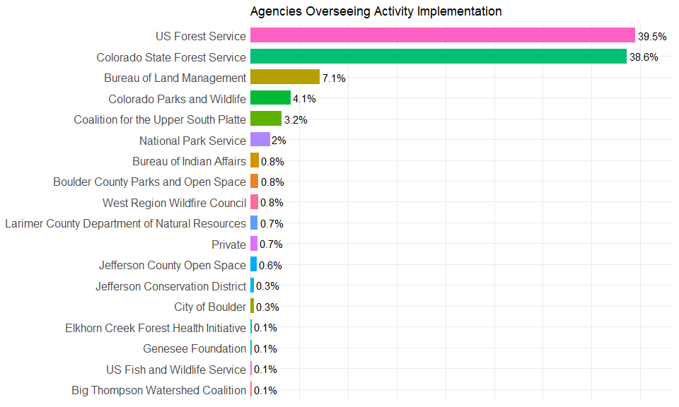

2.2 MGT_TYPE
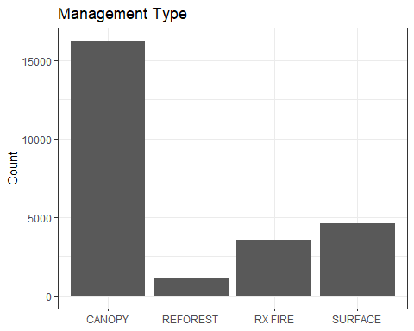
These four management types are further broken into categories in separate columns. The categories for the three management types having to do with fuels reduction are evaluated below.

2.2.3 RXFIRE_MGT
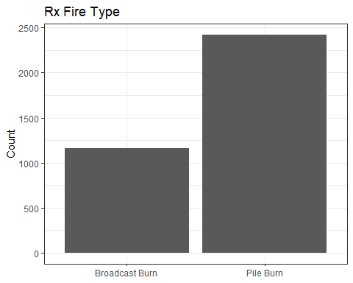

2.2.4 CANOPY_MGT
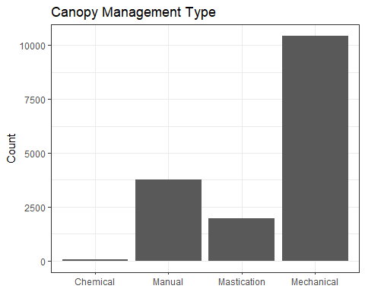

2.2.5 SURF_MGT
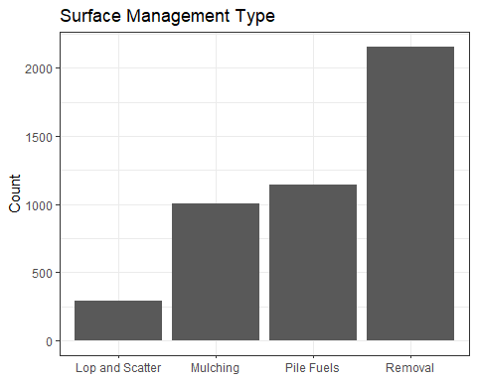

2.3 YEAR_COMP
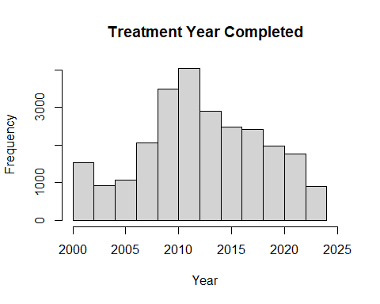
Years Range:
## [1] 2000 2023

2.4 FOR_TYPE
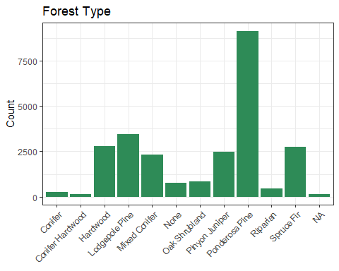

2.5 ACRES_MGT
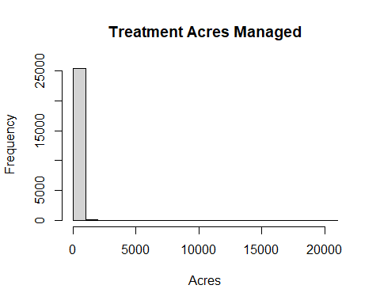
The distribution of acres is extremely skewed toward 0. Using a log scale here makes the distribution normal, if we end up wanting to do that.
Mean Acres:
## [1] 60.80677
Box plot:
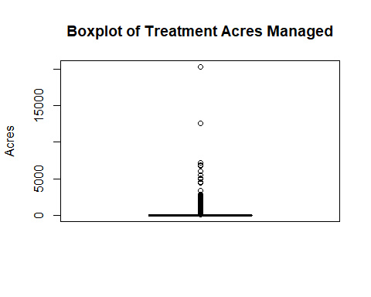
Mean without top 2 outliers:
## [1] 59.5253
The mean is nearly the same (difference of 1.3 acres) with or without the 2 highest outliers, so they don’t influence that too much. The top outlier is in pinyon-juniper so we will end up filtering it out anyway.

3. Questions

3.1 Who is burning?
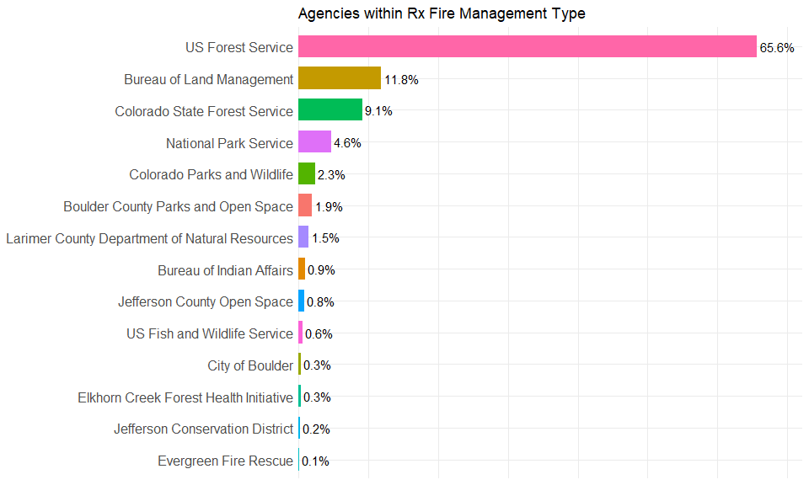

3.2 What is the average acreage of each treatment type?
Treatment Type | Mean Acres
CANOPY | 48.40
RX FIRE | 150.44
SURFACE | 40.14
Let’s also check size of broadcast burning versus pile burning.
Rx Fire Type | Mean Acres
Broadcast Burn | 333.26
Pile Burn | 63.11

Appendix
library(knitr)
knitr::opts_chunk$set(echo = FALSE)
knitr::opts_chunk$set(message = FALSE)
knitr::opts_chunk$set(root.dir = 'C:/Users/Elizabeth Buhr/Documents/fuels-analysis/')
#load packages
library(sf)
library(tidyverse)
library(ggplot2)
#path to file (accessed 10/2/25)
treats_path <- "data/CO_Forest_Tracker_2024/CO_Forest_Tracker_2024.gpkg"
#check layer name
st_layers(treats_path)
#save the layer
treats <- st_read(treats_path, layer = "forest_tracker_v1_2024")
#inspect the columns/structure of the layer
str(treats)
#Agency Bar Chart
agency_df <- treats %>%
st_drop_geometry() %>%
group_by(AGENCY) %>%
summarise(Count = n()) %>%
mutate(
Percent = Count / sum(Count),
PercentRounded = round(100 * Percent, 1),
Label = paste0(PercentRounded, "%")
) %>%
filter(PercentRounded > 0) %>% # Remove agencies with 0.0%
arrange(Percent) # Smallest to largest
# Plot
ggplot(agency_df, aes(x = reorder(AGENCY, Percent), y = Percent, fill = AGENCY)) +
geom_bar(stat = "identity", width = 0.7, show.legend = FALSE) +
geom_text(aes(label = Label), hjust = -0.1, size = 4) +
scale_y_continuous(labels = scales::percent_format(), expand = expansion(mult = c(0, 0.1))) +
labs(
title = "Agencies Overseeing Activity Implementation",
x = NULL,
y = NULL
) +
coord_flip() +
theme_minimal() +
theme(
axis.text.x = element_blank(), # removes percent labels
axis.ticks.x = element_blank(), # removes tick marks
axis.text.y = element_text(size = 12)
)
# MGT_TYPE barplot
ggplot(treats, aes(x = MGT_TYPE)) +
geom_bar() +
theme_bw() +
labs(title = "Management Type", x = NULL, y = "Count")
# RXFIRE_MGT barplot
rxfire_df <- treats %>%
st_drop_geometry() %>%
filter(!is.na(RXFIRE_MGT) & RXFIRE_MGT!= "" & RXFIRE_MGT != " ")
ggplot(rxfire_df, aes(x = RXFIRE_MGT)) +
geom_bar() +
theme_bw() +
labs(title = "Rx Fire Type", x = NULL, y = "Count")
# CANOPY_MGT barplot
canopy_df <- treats %>%
st_drop_geometry() %>%
filter(!is.na(CANOPY_MGT) & CANOPY_MGT!= "" & CANOPY_MGT != " ")
ggplot(canopy_df, aes(x = CANOPY_MGT)) +
geom_bar() +
theme_bw()+
labs(title = "Canopy Management Type", x = NULL, y = "Count")
# SURF_MGT barplot
surf_df <- treats %>%
st_drop_geometry() %>%
filter(!is.na(SURF_MGT) & SURF_MGT!= "" & SURF_MGT != " ")
ggplot(surf_df, aes(x = SURF_MGT)) +
geom_bar() +
theme_bw()+
labs(title = "Surface Management Type", x = NULL, y = "Count")
# YEAR_COMP histogram
hist(treats$YEAR_COMP, main = "Treatment Year Completed", xlab = "Year", xlim = c(2000,2025))
range(treats$YEAR_COMP)
# FOR_TYPE barplot
ggplot(treats, aes(x = FOR_TYPE)) +
geom_bar(fill = "seagreen") +
theme_bw() +
labs(title = "Forest Type", x = NULL, y = "Count") +
theme(axis.text.x = element_text(angle = 45, hjust = 1))
#histogram of ACRES_MGT
hist(treats$ACRES_MGT, main = "Treatment Acres Managed", xlab = "Acres")
#but mean is small
mean(treats$ACRES_MGT)
#we can see there are a couple outliers
boxplot(treats$ACRES_MGT, main = "Boxplot of Treatment Acres Managed", ylab = "Acres")
treats_sorted <- treats[order(-treats$ACRES_MGT), ]
treats_trimmed <- treats_sorted[-c(1, 2), ]
#check out mean without the outliers and compare it to the mean with them
mean(treats_trimmed$ACRES_MGT, na.rm = TRUE)
#RX Burn Agency
AgRx_df <- rxfire_df %>%
st_drop_geometry() %>%
group_by(AGENCY) %>%
summarise(Count = n()) %>%
mutate(
Percent = Count / sum(Count),
PercentRounded = round(100 * Percent, 1),
Label = paste0(PercentRounded, "%")
) %>%
filter(PercentRounded > 0) %>% # Remove agencies with 0.0%
arrange(Percent) # Smallest to largest
# Plot
ggplot(AgRx_df, aes(x = reorder(AGENCY, Percent), y = Percent, fill = AGENCY)) +
geom_bar(stat = "identity", width = 0.7, show.legend = FALSE) +
geom_text(aes(label = Label), hjust = -0.1, size = 4) +
scale_y_continuous(labels = scales::percent_format(), expand = expansion(mult = c(0, 0.1))) +
labs(
title = "Agencies within Rx Fire Management Type",
x = NULL,
y = NULL
) +
coord_flip() +
theme_minimal() +
theme(
axis.text.x = element_blank(), # removes percent labels
axis.ticks.x = element_blank(), # removes tick marks
axis.text.y = element_text(size = 12)
)
treats %>%
st_drop_geometry() %>%
filter(MGT_TYPE %in% c("CANOPY", "RX FIRE", "SURFACE")) %>%
group_by(MGT_TYPE) %>%
summarise(
avg_acres = mean(ACRES_MGT, na.rm = TRUE)
) %>%
arrange(MGT_TYPE) %>%
mutate(avg_acres = round(avg_acres, 2)) %>%
kable(col.names = c("Treatment Type", "Mean Acres"), align = "lc")
rxfire_df %>%
group_by(RXFIRE_MGT) %>%
summarise(
avg_acres = mean(ACRES_MGT, na.rm = TRUE)
) %>%
arrange(RXFIRE_MGT) %>%
mutate(avg_acres = round(avg_acres, 2)) %>%
kable(col.names = c("Rx Fire Type", "Mean Acres"), align = "lc")

